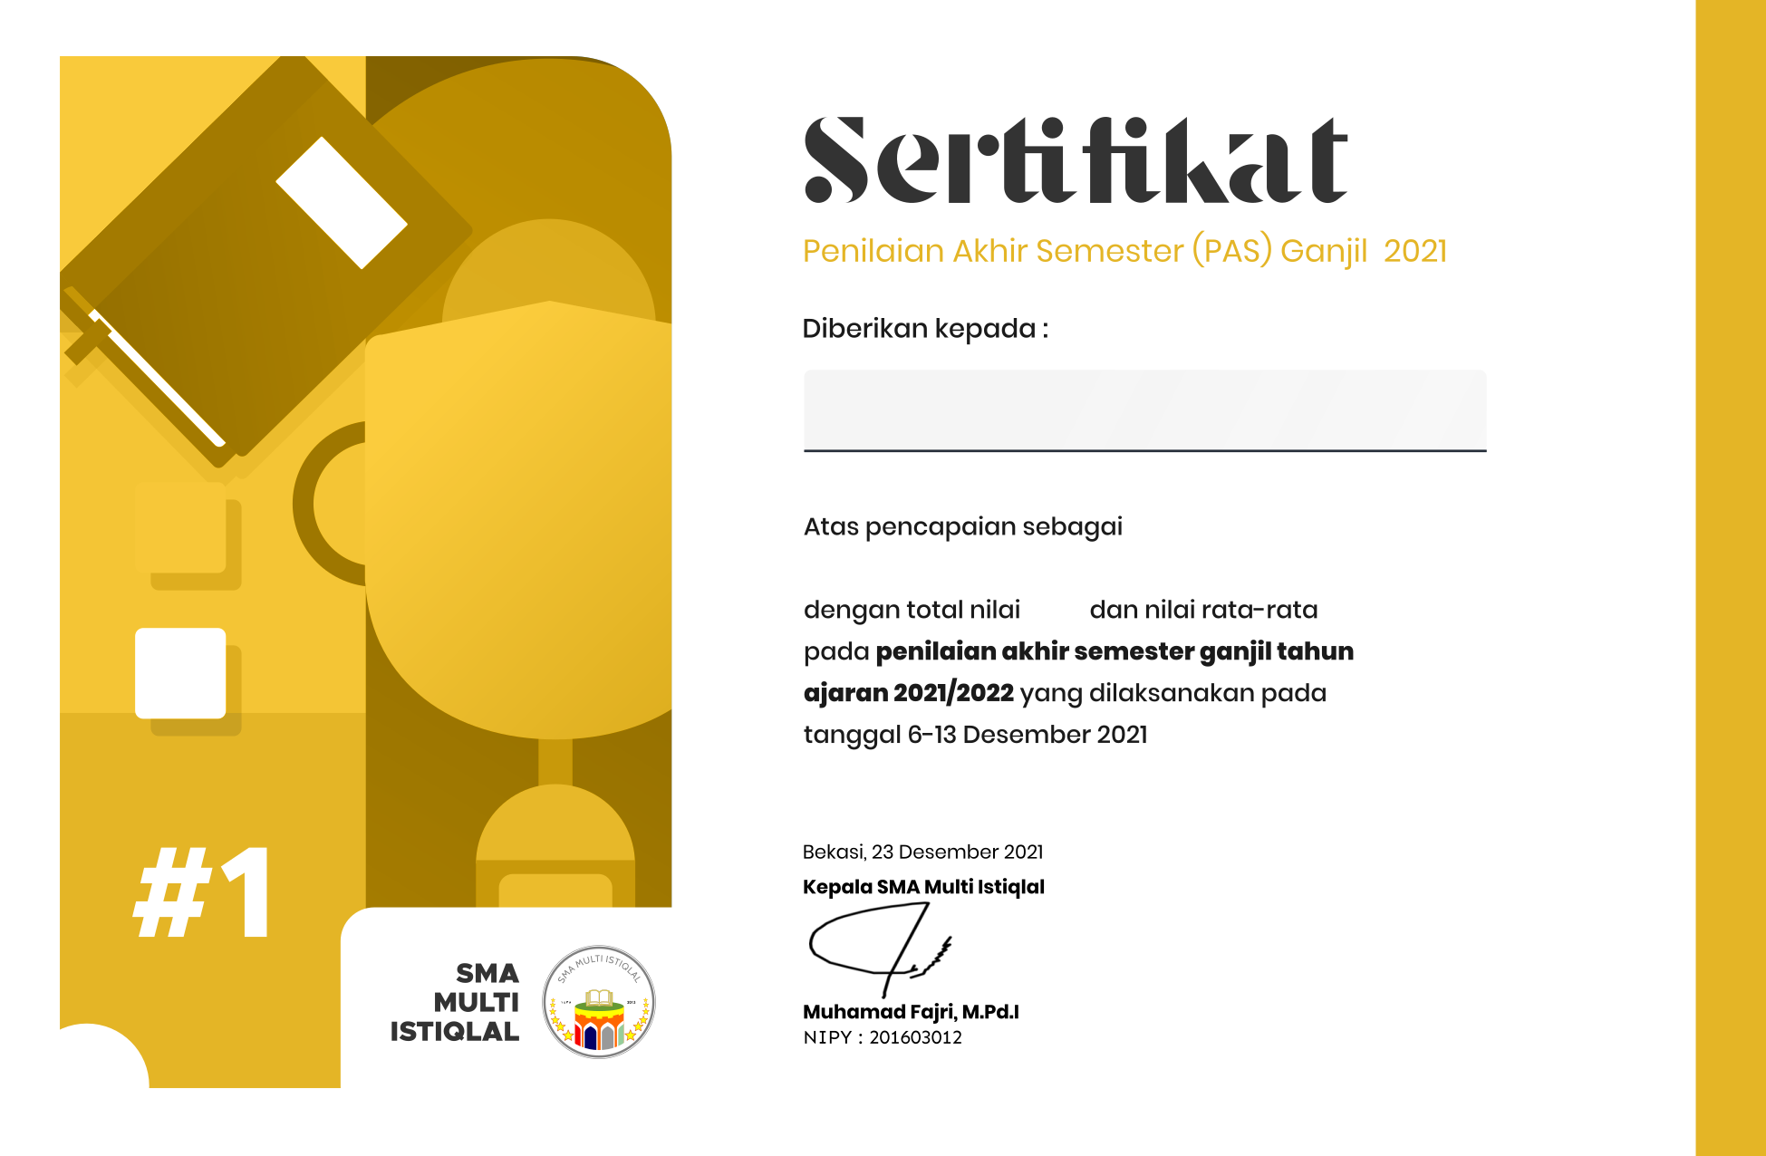

**Syuhada Ammar Yasir Ramadhan**

**84,640000000000001973**

**2454**

**Juara I Kelas X Ikhwan**